VPC Challenge
- Design and deploy a scalable network architecture using AWS Transit Gateway to simplify network connectivity between multiple VPCs.
Create 3 vpc including with IP address
My-vpc-1 – 10.0.0.0/24
My-vpc-2 – 10.0.1.0/24
My-vpc-3- 10.0.2.0/24
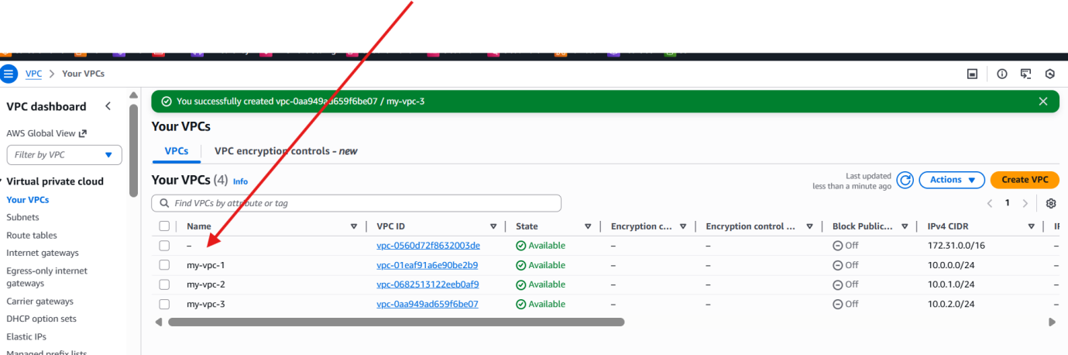

Create 3subnets
Subnet-2
Subnet-2
Subnet-3
For each VPC attach to the subnet
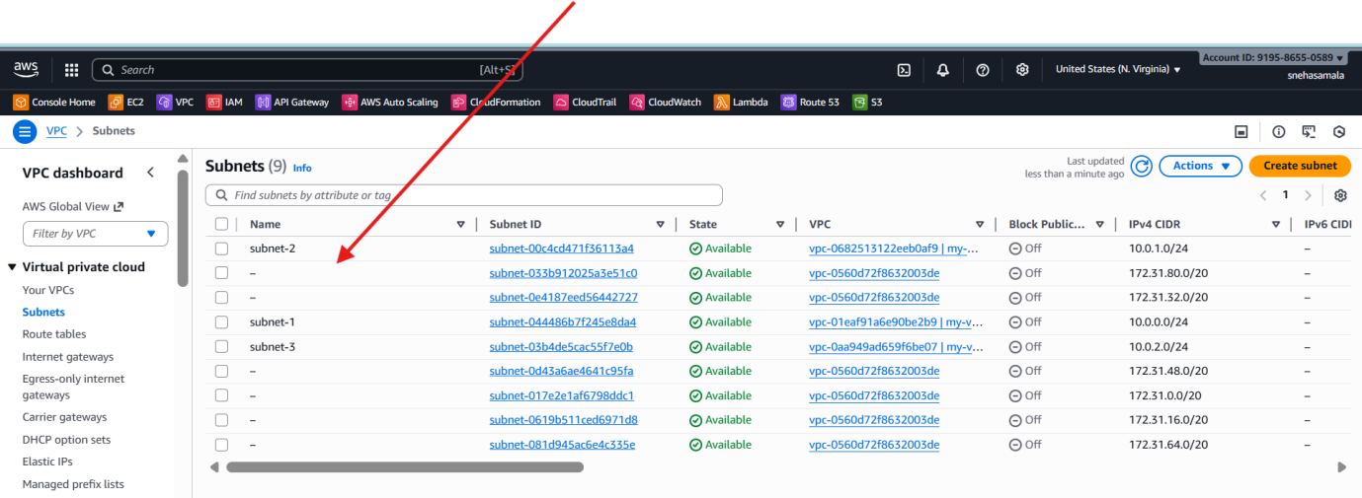
Create 3 ec2
With attach VPC’s
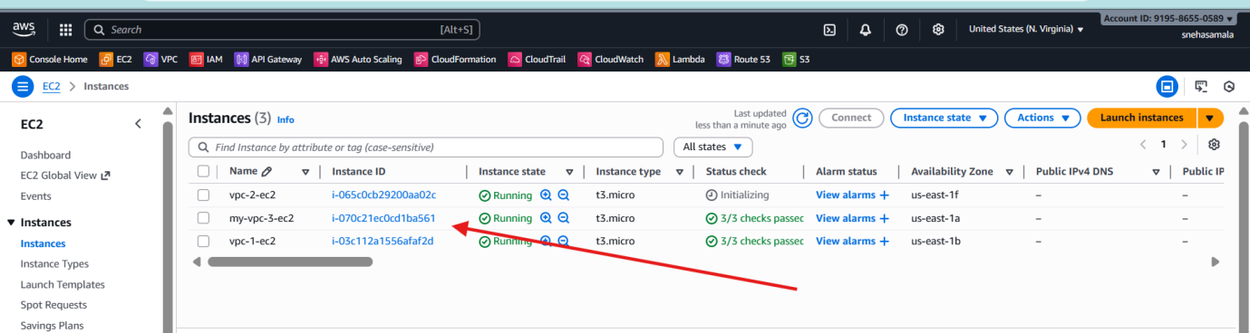
Allow all traffic
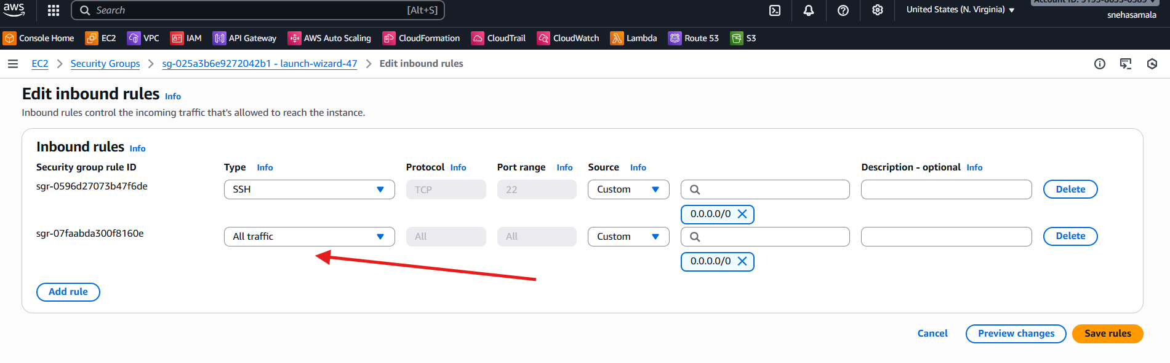
Create transit gate ways with attach the vpc
For every 1 transit gateway attach vpc
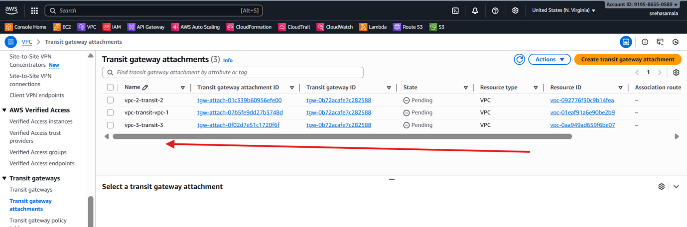
Create RT
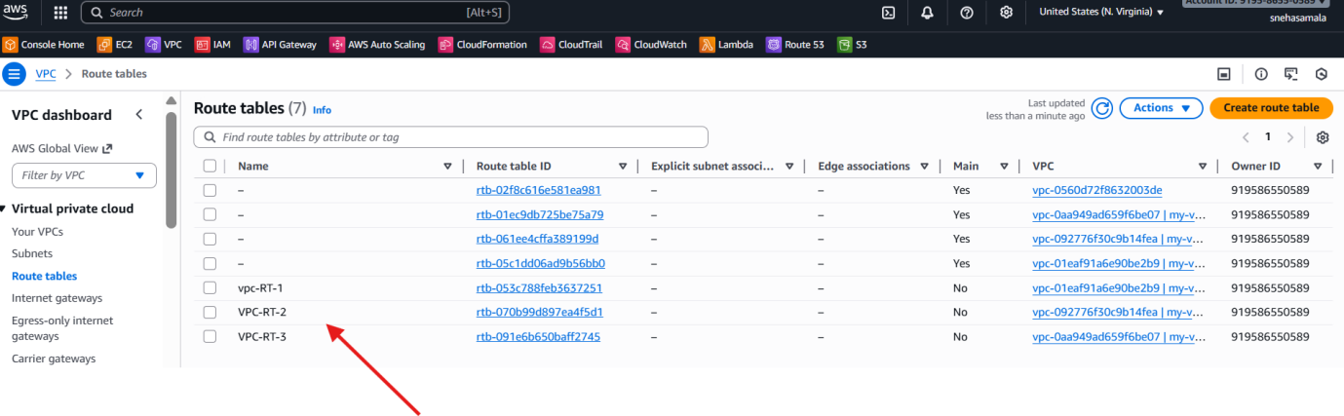
Edit the RT
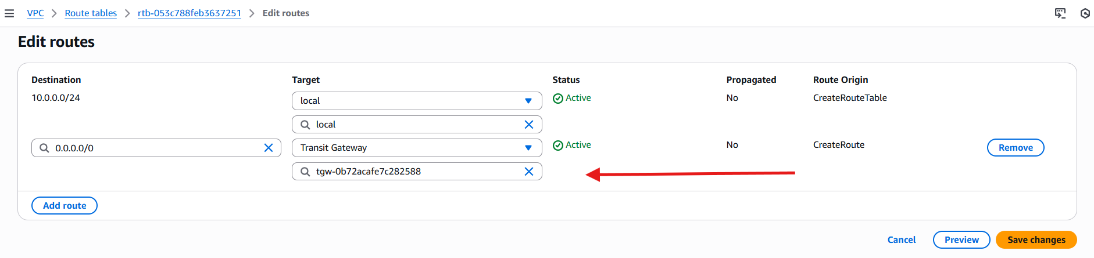
Create 3 IGW’S

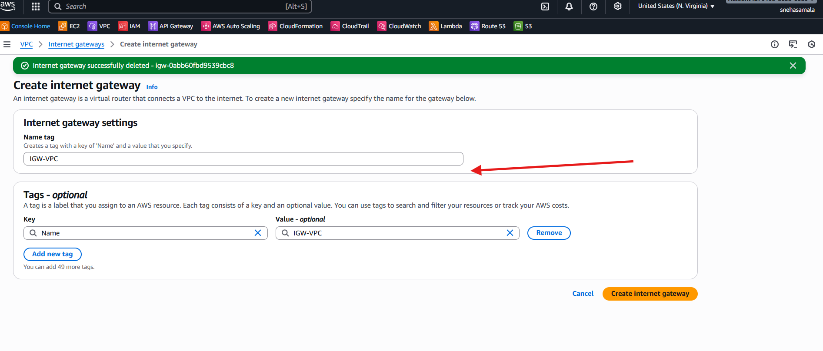
Attach to the vpc
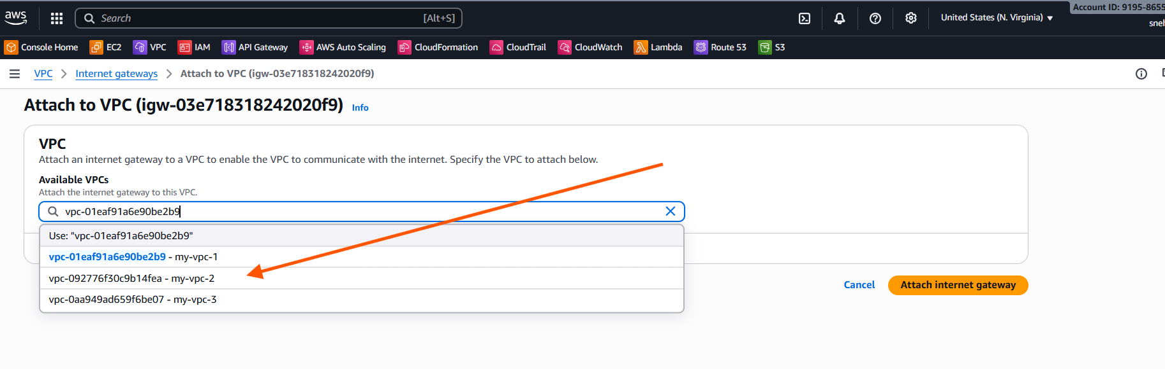
Successfully attached
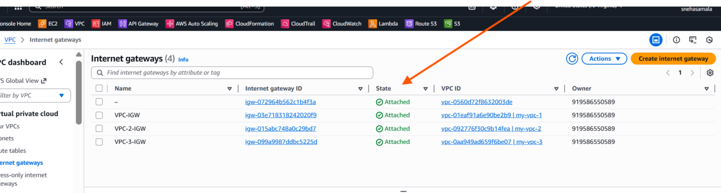
Add rt to inyernet gate way
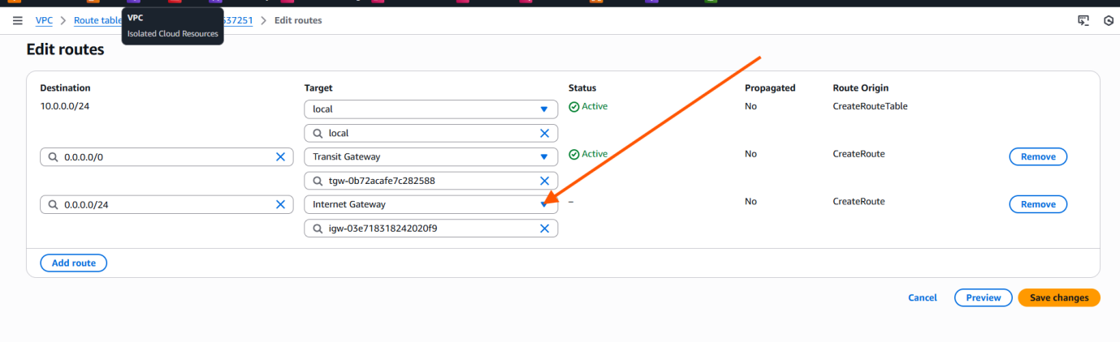
Connecting successfully
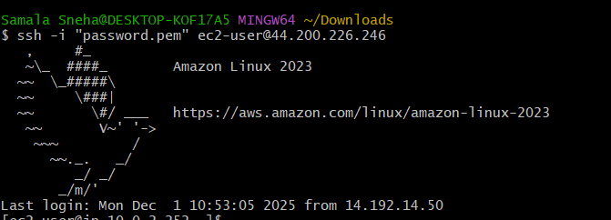
Connected ec2-2
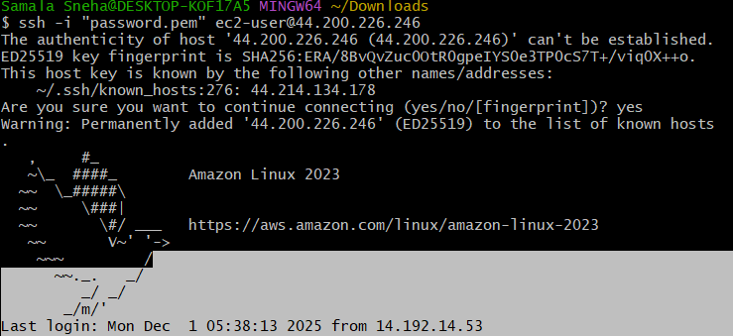
Ec2-vpc-2
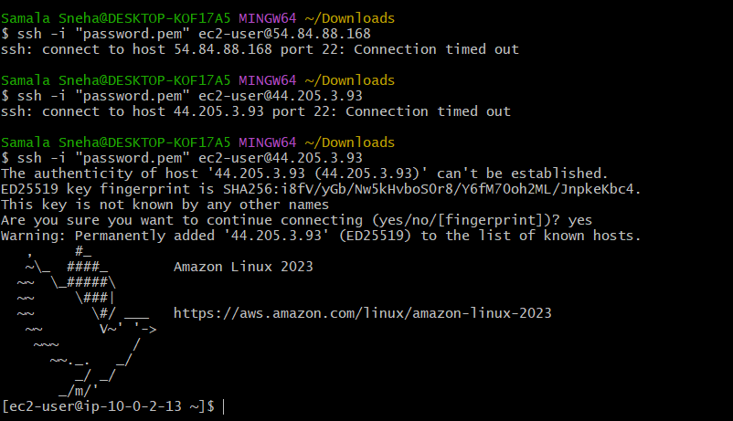

- Configure VPC endpoints to securely access AWS services without internet gateways or NAT gateways, ensuring data privacy and minimizing exposure to external threats.
Allow private access AWS Services
AWS consol --> S3-Bucket --> create s3bucket (give unic name)

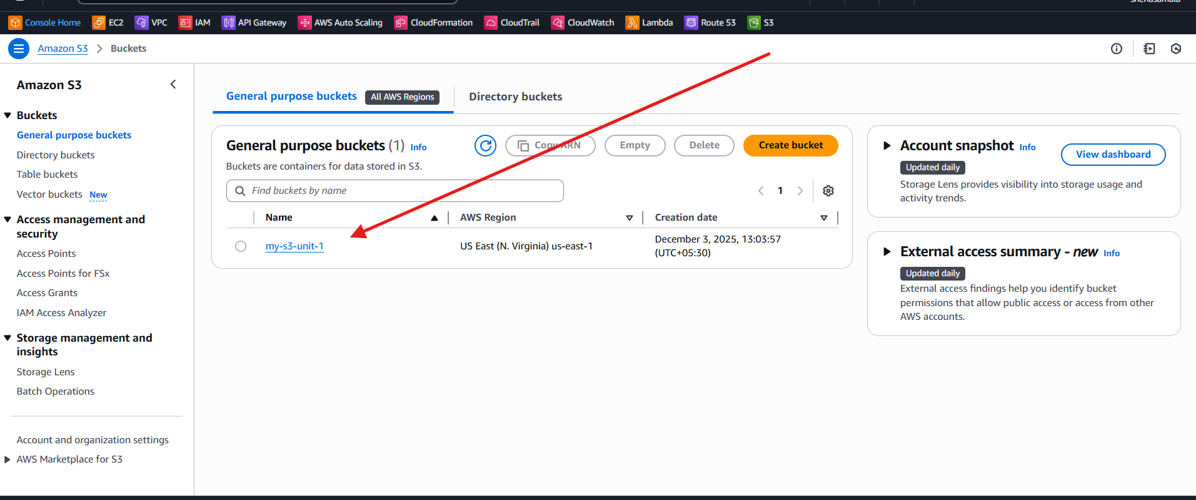
Go to the aws ACCOUNT ID -->select security credentials
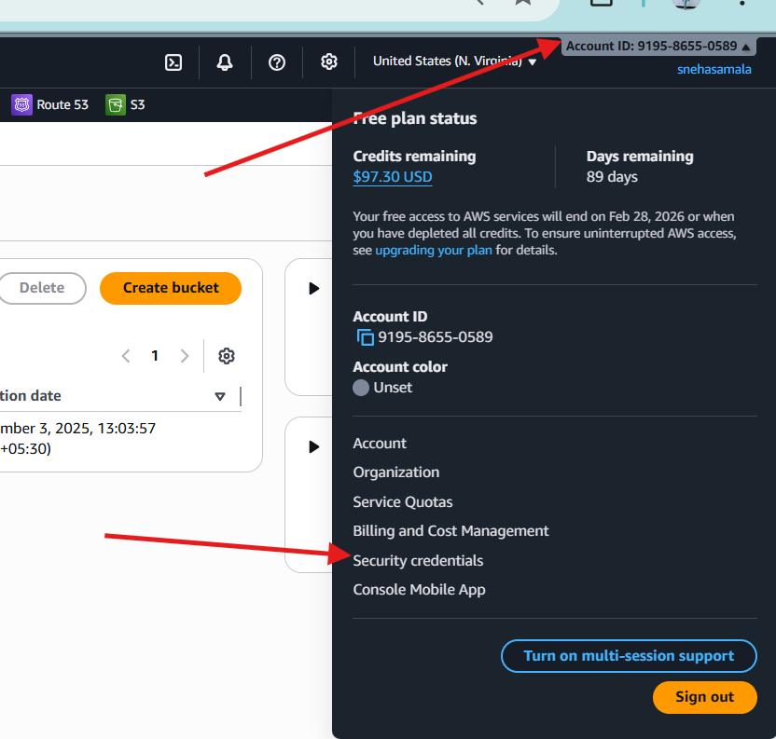
Create access key

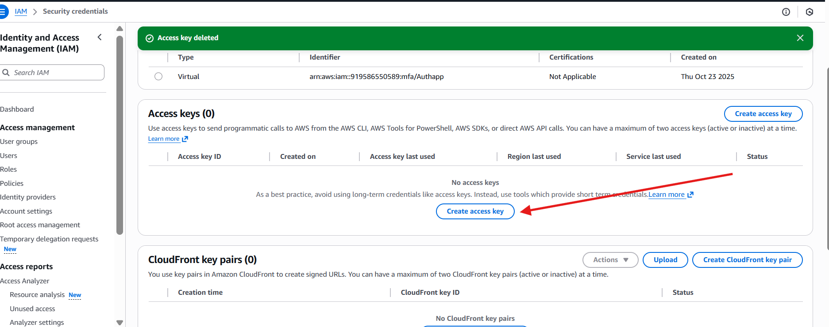
Continue to create access key

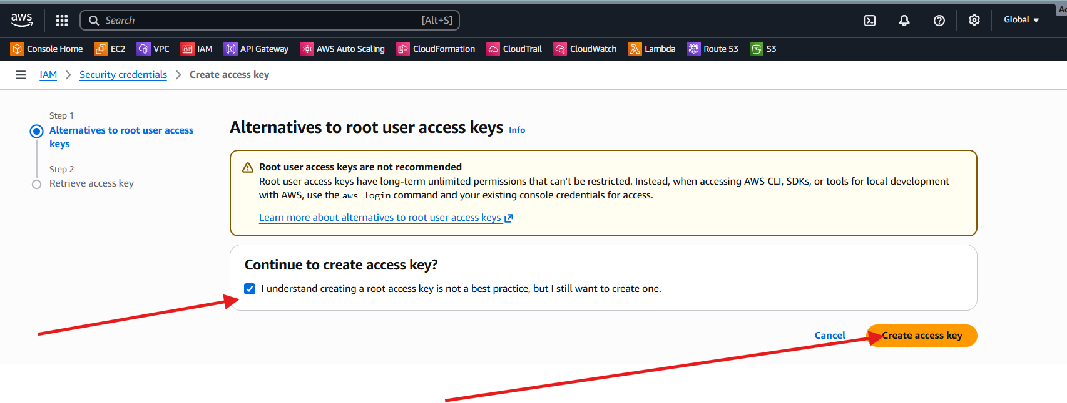
Access key is created
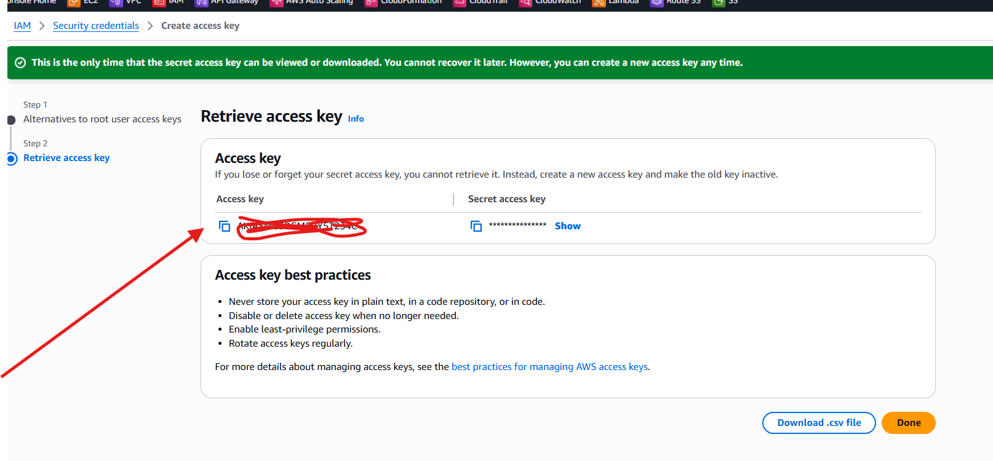
VPC -->Endpoint --> name-tag-optional -->type(AWS Services)

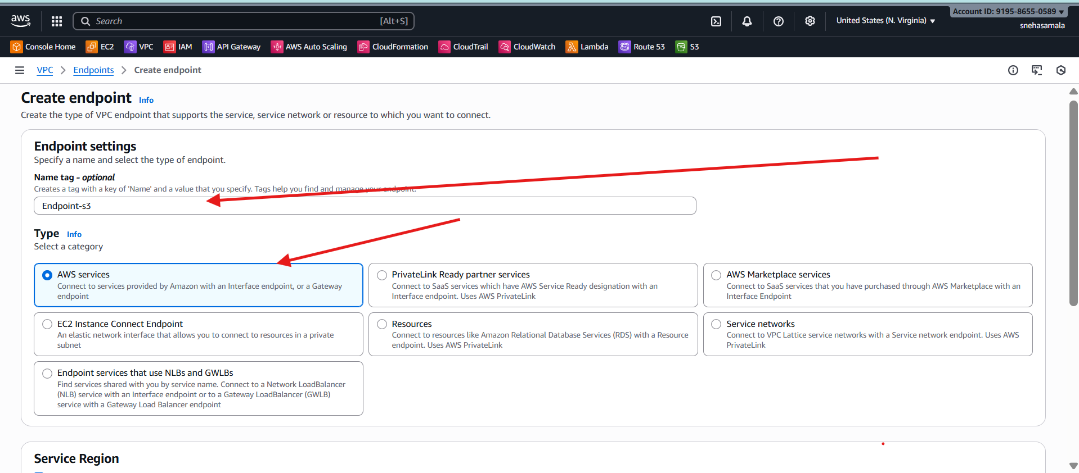
Service --> com.amazonaws-us-east-1.s3
Select default vpc
Rout Table default
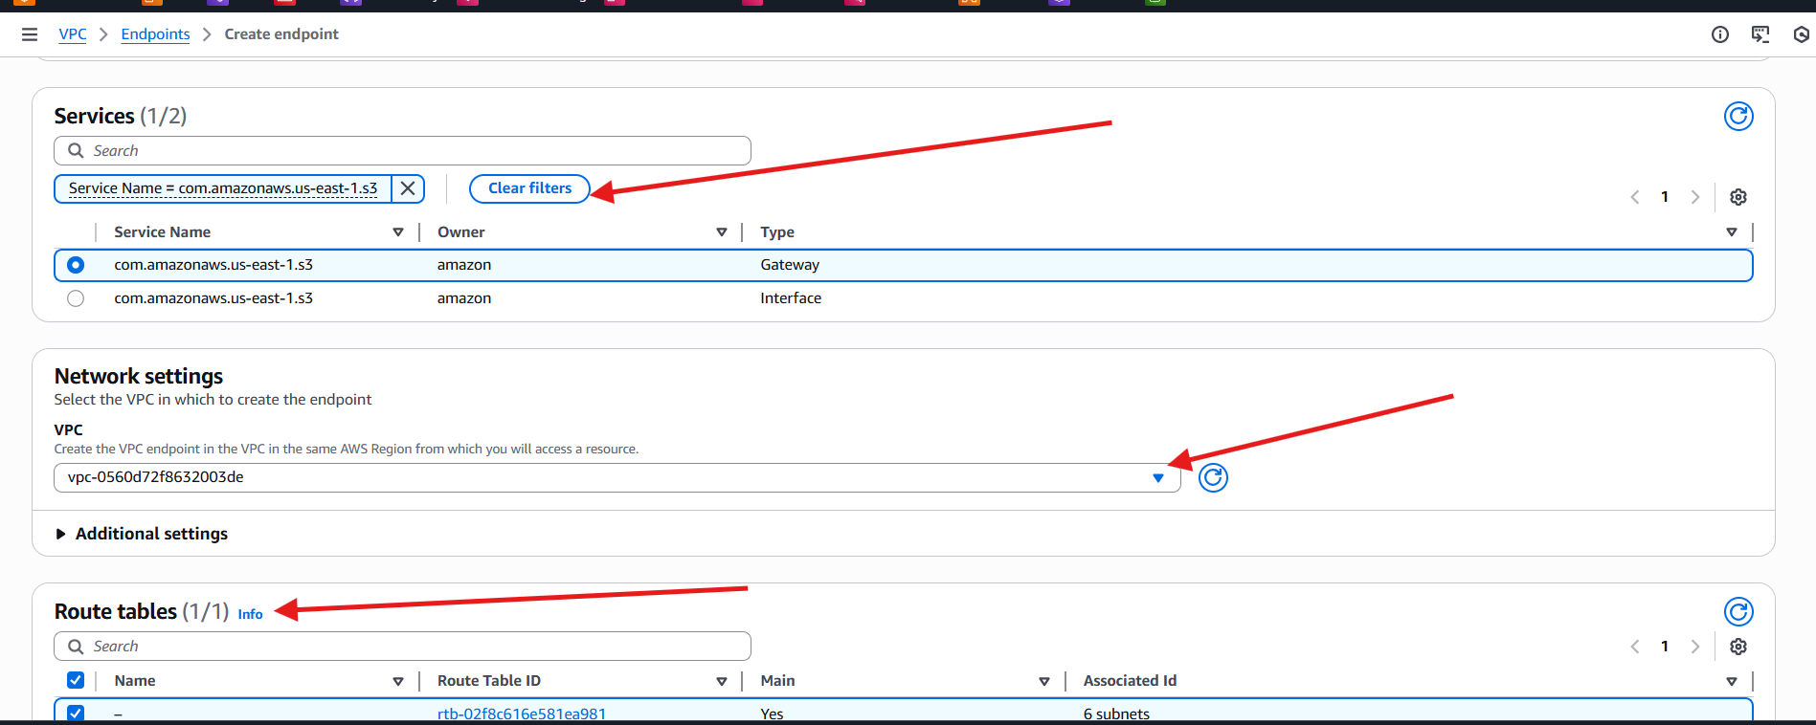
Policy --> full access
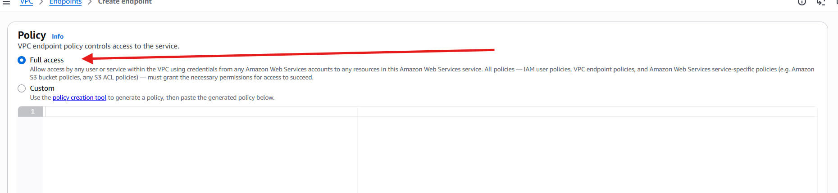
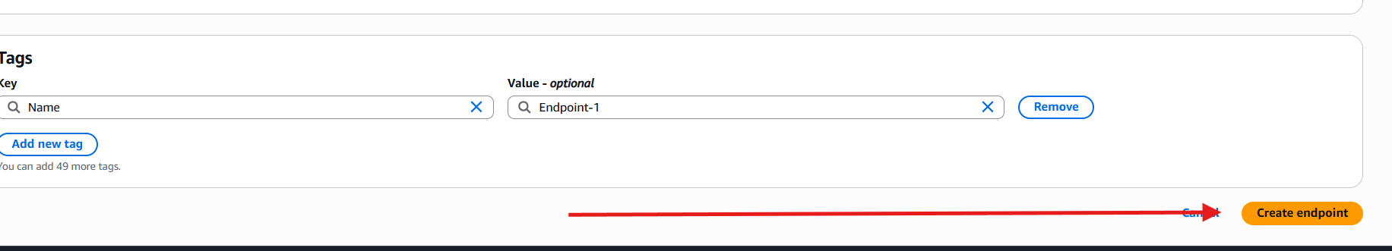
Launch 2 ec2 instances
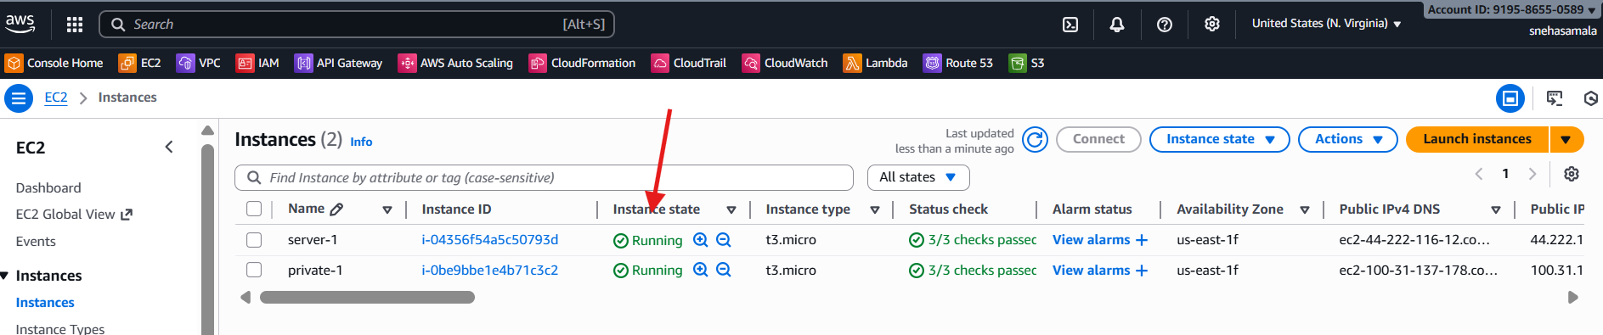
Connect to the git bash with frst ec2 instance
Aws configure : it will configre the
Access key id
Secure acess id
Region (give what reginon u r working
Default format : json
Then do
Aws s3 ls
It will show u r created bucket
An create one pem key :name ---> test.pem--> copy u r pem key and paste and save it
Give permissions chmod 600 test.pem
And connect with that key
Connect with another ec2
Aws configure
Access id
Secure key
Region
Aws s3 ls
It will give the access
